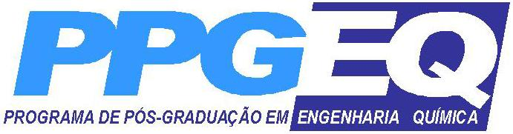

Universidade Federal do Rio Grande do Norte
Centro de Tecnologia

Departamento de Engenharia Química
Programa de Pós Graduação em Engenharia Química

Disciplina: PEQ-4031 – SEMINÁRIOS DE PETRÓLEO E GÁS NATURAL
Carga Horária: 45 horas (3 Créditos)
Prof. Responsável: Afonso Avelino Dantas Neto

Ementa:
Exploração, perfuração, produção e refino de petróleo; refino do petróleo; petroquímica: fertilizantes e lubrificantes; processamento e distribuição do gás natural; meio ambiente; prestação de serviços na indústria de petróleo.

Bibliografia:
1. Mnning, F. F., Thompson, R. – Oil field processing of petroleum. Vol. 1 (Natural gás), Vol. 2 (Petroleum).
2. Leinz, V., Amaral, E. – Geologia geral. 5 ed., São Paulo: Editora Nacional, 1974.
3. Sitter, L. U. – Geologia estrutural. 5 ed., Barcelona: Ômega.
4. Beloussov, V.V. – Problemas básicos de geotectônica. Barcelona: Ômega.
5. Williams, J. – Oceanography: an introduction to the marine science. EUA: Brown and Company Limited. Lybrary of Congress Catalog Nº 6218105, 1962.
6. Clark, N. J. – Elements de petroleum reservoirs. Dallas: Storm Printing Company. Henry L. Doherty Series.
7. Mcgray, A. W., Cole, F. W. – Oil well drilling technology. 1 ed., EUA: University of Oklahoma Press. Lybrary of Congress Catalog Nº 59-7486, 1959.
8. Gatlin, C. – Petroleum engineering: drilling and well completions. EUA: Printice Hall, Englewoods Clifs. Lybrary of Congress Catalog Card Nº 60-6874, 1960.
9. Zaba, J., Doherty, W.T. – Practical petroleum engineers handbook. 15 ed., Houston: Gulf Publishing Company. Lybrary of Congress Catalog Card Nº 58-12306.
10. Bobo, R. A., et al. – Keys to success ful competitive drilling. Houston: Gulf Publishing Company. Lybrary of Congress Catalog Card Nº 58-9835, 1958.
11. Short, J. A. – Drilling and casing operations. Oklahoma: Pen Well Publishing Company. Lybrary of Congress Catalog Card Nº 81-14386, 1982.
12. Moore, P. L. – Drilling practices manual. Oklahoma: Pen Well Publishing Company. Lybrary of Congress Catalog Card Nº 7480-812, 1974.
13. Mauer, W. C. – Advanced drilling techniques. Oklahoma: Petroleum Publishing Company. Lybrary of Congress Catalog Card Nº 79-53582, 1980.
14. Harris, L. M. – An introduction to deepwater floating drilling operation. Oklahoma: Petroleum Publishing Company. Lybrary of Congress Catalog Card Nº 72-76603, 1972.
15. Eta offshore seminars, inc. The technology of offshore drilling, completions and production. Oklahoma: Pen Well Publishing Company. Lybrary of Congress Catalog Card Nº 75-21903, 1976.
16. Petroleum transations reprint series. Number 6: drilling. Printed by the Society of Petroleum Engineers of AIME.

